New Copan eSwab for Bacteriology samples.

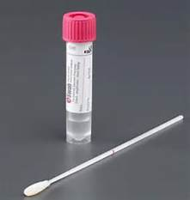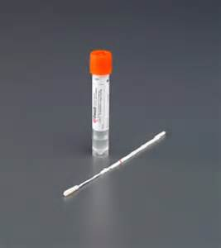
IMPORTANT:

DO NOT USE FOR MRSA SCREENING

MRSA SCREENING PACKS CAN BE ORDERED FROM PATHOLOGY SUPPLIES IF NEEDED
Orange cap Liquid Amies Single Swabs.
Use for Ear swab culture and urethral swabs only.

Pink cap Liquid Amies Single Swabs.
Use for Microbiology Culture and Sensitivity (MMCS) Investigations
Collection from: wound, skin, nose, throat, eyes, mouth, vaginal

Break swab shaft at coloured breakpoint and leave swab in tube

Unscrew cap and insert swab into the liquid in the tube.
Remove swab from pack and take sample

3
REMEMBER:

- Liquid must remain in the tube - this is what is tested
- White swab must be in the tube - this is how we know a sample has been taken
- Always ensure samples are labelled fully.
Label tube with full patient ID or OrderComms label placed vertically on tube.
Screw the cap tight onto the tube

