
EDS Ratings & Scores
Refer to Pages 17 to 24 in the EDS Ratings and Score Card Guidance for a full explanation of the new rating and scoring procedure and to ensure ratings and scores are correct.

Each outcome must be scored and all scores of all outcomes added together. This will provide the overall score and the EDS Organisation Rating. Ratings in accordance to scores are below:
Undeveloped activity – organisations score 0 for each outcome | Those who score under 8, adding all outcome scores in all domains, are rated Undeveloped
Developing activity – organisations score 1 for each outcome | Those who score between 8 and 21, adding all outcome scores in all domains, are rated Developing
Achieving activity – organisations score 2 for each outcome | Those who score between 22 and 32, adding all outcome scores in all domains, are rated Achieving
Excelling activity – organisations score 3 for most outcomes | Those who score 33, adding all outcome scores in all domains, are rated Excelling

Domain 1: Commissioned or provided services evidence

Domain 1 | Outcome | Evidence | Score/  Rating | Owner/Lead
Commissioned or Provided Services Evidence | 1A: Patients (service users) have required levels of access to the service | Cystic Fibrosis  - Patients can contact the ward 24 hours a day via telephone to request next-day appointments.  - Emergency access is available through the Emergency Department (ED) in line with standard clinical protocols and same day admission can be arranged via consultant clinic review or telephone.  - In 2024, there were over 2100 clinic appointments for 440 patients (500 appointments were virtual)  - In 2024 the overall DNA rate was 10.19% however when this is broken down further, 21% of those patients are young people. It is thought that this is due to appointments being scheduled on weekdays, when they may be attending education.  - Adjustments are made for patients with Learning Disabilities and/or autism which include Home Visits. Environmental adjustments are also made prior to attending clinic if this is required.  - Direct email access to the Clinical Nurse Specialist (CNS), Physio and Dietetic team.  - The service has a dedicated CF Psychologist.  - Individualised exercise programs including a low-impact exercise class tailored to CF needs  - Patients who are competent, or who have a trained carer, can access home intravenous (IV) treatment to support flexibility and reduce hospital attendance.  - Opportunity for Carers and guardians to be trained to deliver treatment to patients at home. | 2  Achieving | Jason Swarbrooke, Senior Charge Nurse
Commissioned or Provided Services Evidence |  | Dementia in Older Adults (PLWD = People Living with Dementia)  - Any help required with e.g. communication is identified on referral and admission.  - Work has commenced to resolve difficulties in identifying PLWD in Outpatients.  - Easy read letters are now in use as standard.  - If the PLWD has an Outpatient appointment within Older Persons’ Medicine, then they do not use patient hub and as part of their system every patient gets a phone call 48 hours before their appointment to check they are attending and to understand any issues. This has reduced DNA rates.  - A reasonable adjustment care plan is in development with LD and Autism colleagues.  - We participate in PLACE (Patient-Led Assessment of Care Environment) and PLACE lite inspections which contain specific questions around dementia.  - We are working with the Age Friendly Steering Group to visit and use the Leeds Older People’s Forum Age Friendly and Dementia Checklist.  - AccessAble review disabled access and facilities Trust wide and we are able to audit this.  - We are currently working with Leeds Beckett Dementia Research Centre on a National research project involving experiences of outpatients and development of a toolkit for staff. | 2  Achieving | Alison Raycraft, Lead Nurse for Older People
Commissioned or Provided Services Evidence |  | Supporting Deaf Patients  - Staff and colleagues are supported to make bookings for in-person BSL Interpreters to attend hospital premises in any of the five sites across Leeds.  - Staff and colleagues have access to virtual BSL interpreters via apps on iPads, mobile phones and/ or via the web.  - Patients and service users in the community have access to the virtual service so that they can contact the Trust using BSL.  - Patients can use the virtual service to submit feedback or make a complaint, either directly to the Trust or via the approved provider, who would relay the concern or complaint directly to the Interpreting team.  - Patients and service users have access to the PALS Service Text Phone number. The PALS team can relay messages on behalf of the patient where they are not able to respond directly. | 2  Achieving | Alison Sherry, Interpreting Services Manager

Domain 1 | Outcome | Evidence | Score/  Rating | Owner/Lead
Commissioned or Provided Services Evidence | 1B: Individual patients (service users) health needs are met | Cystic Fibrosis  - Learning Disabilities (LD), race, gender, and sexuality are recorded on the Patient Pathway Manager (PPM) system. Some demographic data is still missing from EMIS records, and work is ongoing to improve completeness.  - All patients have their preferred name and pronouns recorded on EMIS.  - The service adopts an individualised approach to care, rather than standardised protocols, enabling flexibility to meet the unique needs of each patient.  - For patients with LD, care plans are tailored with additional staff support during admissions. Engagement tools such as a Nintendo Switch and other activities are available to support comfort and reduce anxiety.  - All patients have access to the full MDT, including a Medical Social Worker (MSW), psychologist, physiotherapist, dietitian, and Clinical Nurse Specialist (CNS).  - At outpatient MDT clinic appointments, all patients are reviewed by a physiotherapist, dietitian, and CNS. Home visits are offered when patients are unable to travel.  - All inpatients receive daily physiotherapy and are reviewed by a dietitian five days per week.  - All patients receive an annual review to assess clinical status, treatment plans, and wider health needs  - Ward J06 operates an open visiting policy and provides facilities for carers to stay overnight, including camp beds.  - Chaplaincy services are available to patients of all faiths.  - Medication plans are adapted for patients whose religious beliefs preclude certain ingredients (e.g., pork-derived products).  - Individual rooms for Praying and signage available to give privacy  - Pregnant patients are referred to Leeds Maternity Services for a shared-care model due to the higher risk associated with pregnancy in CF.  - Reserved parking spaces for CF patients are available at the front of St James’s University Hospital.  - All inpatient wards provide single rooms with en-suite facilities to support privacy, infection control, and comfort.  - Ward has a gym, laundry and kitchen facilities available on the ward. | 2  Achieving | Jason Swarbrooke, Senior Charge Nurse
Commissioned or Provided Services Evidence | 1B: Individual patients (service users) health needs are met | Dementia in Older Adults (PLWD = People Living with Dementia)  - Nursing and medical assessments are completed on admission to identify health needs. Questions are asked re dementia diagnosis, memory and delirium. Risks to health are identified and risk reduction strategies put in place.  - Several professionals are involved in the care, and we have a large Older People’s Liaison Service that supports our care and treatment.  - To help us identify that someone has dementia or has significant memory problems we use a ‘forget -me -not magnet’ in inpatient areas.  - To understand the range of needs and provide individualised care for PLWD or significant memory problems we are promoting personalised documents and ask carers to bring in /staff to facilitate the ‘This is Me’ document for inpatients and the new ‘Know who I am’ document for Outpatients. These are being added to RISE accreditation to embed the use more fully.  - We have 135 dementia champions across diverse roles.  - We have Easy Read information and interpreters are available.  - People with a dementia that have LD are supported by the LD and Autism team.  - Most nursing staff who were new received training in dementia that was face to face last year and e-learning dementia training is available for all staff to access and for refreshers.  - We work very closely with Carers Leeds (have 2 Carer Support Workers), Age Uk (Hospital to home, Home Comforts.  - We have 3 Johns Campaign ambassadors that can support. | 2  Achieving | Alison Raycraft, Lead Nurse for Older People
Commissioned or Provided Services Evidence | 1B: Individual patients (service users) health needs are met | Supporting Deaf Patients  - In-person face-to-face BSL Interpreters are booked ahead of a patient’s appointment.  - Virtual BSL Interpreters are used to communicate with patients who are in hospital on a ward and vice versa.  - The app downloaded onto Trust mobiles and Trust iPads is used to access BSL Interpreters where a patient attends unexpectedly, such as in the Emergency Departments or Maternity services.  - The app can also be used to engage with a patient for reassurance if an in-person Interpreter is delayed or cannot be present, reducing anxiety and frustration.  - All interpreters (face-to-face or virtual) are qualified in BSL to an agreed standard. Student interpreters are not used to convey clinical information. | 2  Achieving | Alison Sherry, Interpreting Services Manager

Domain 1 | Outcome | Evidence | Score/  Rating | Owner/Lead
Commissioned or Provided Services Evidence | 1C: When patients (service users) use the service, they are free from harm | Cystic Fibrosis  - The CF unit recorded 1 fall, 2 pressure ulcer incidents and 3 Healthcare-associated infections within the reporting period. All incidents are reviewed in line with Trust governance procedures to ensure root cause analysis, learning, and prevention measures are implemented.  - All patient deaths are reviewed through the Trust’s governance framework. This includes multidisciplinary discussion to identify learning, enhance patient safety, and improve the quality of care.  - The CF service maintains a proactive approach to harm prevention through continuous monitoring, incident reporting, and staff training.  - Safety performance is reviewed regularly to identify trends and implement targeted quality improvement initiatives. | 2  Achieving | Jason Swarbrooke, Senior Charge Nurse
Commissioned or Provided Services Evidence |  | Dementia in Older Adults (PLWD = People Living with Dementia)  - Governance systems and processes in place, including identifying and sharing the learning. Monitoring and reporting on the harms people living with dementia may experience which includes those we are asked about by the National Audit of Dementia Psychiatry Team.  - Our incident reporting system asks if a patient has a dementia diagnosis. This is being mandated on the system.  - We discuss harms quarterly in our Dementia Steering Group and then e.g. also  at relevant preventing harm groups e.g. the Falls and Pressure Ulcer Prevention steering groups. Safeguarding data is also available and discussed.  - We have undertaken literature reviews to identify if there are interventions that we could use on top of the evidence-based interventions we use already.  - We have focused work on reducing distress to reduce harms.  - Overall incidents involving patients with dementia: 420 less than 2023-2024 a reduction of 20%.  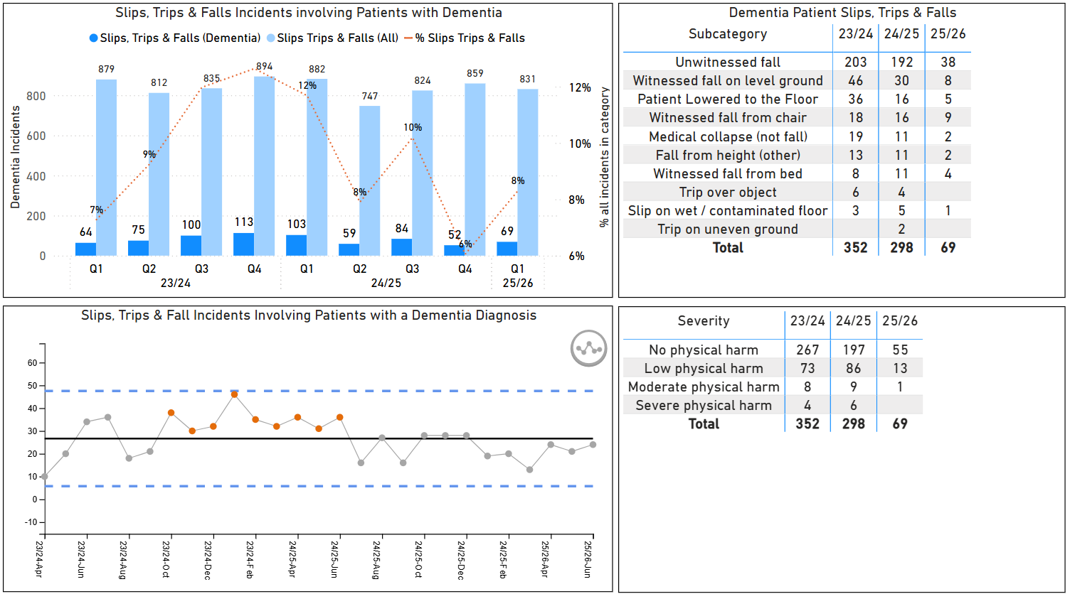  - We have an introduced a delirium strategy for over 65’s.  - We have been HSJ Patient Safety finalists 2025 | 2  Achieving | Alison Raycraft, Lead Nurse for Older People
Commissioned or Provided Services Evidence |  | Supporting Deaf Patients  - The Trust’s providers work to agreed key performance indicators. Among these is an assurance to the Trust that the BSL Interpreters are suitably qualified (to an agreed qualification level).  - Communication of clinical information is only delivered using qualified interpreters, unless a patient has expressly requested the support of a partner or family member. This happens occasionally when the partner or family member is also the patient’s carer. In these circumstances it is documented in the patient’s notes that they have requested and agreed to this. | 2  Achieving | Alison Sherry, Interpreting Services Manager

Domain 1 | Outcome | Evidence | Score/  Rating | Owner/Lead
Commissioned or Provided Services Evidence | 1D: Patients (service users) report positive experiences of the service | Cystic Fibrosis  - 98% of respondents rated their Friends and Family Test experience as “Very Good” or “Good.”  - A patient led focus group meets with the ward manager to discuss service improvements and patient experience feedback  - The group winner of LTHT patient experience award  - The group has been shortlisted at PENNA 2025 for its innovative way of improving patient care and hearing patient voices  - In the last 5 years the Unit has not received PALS or Complaints | 3  Excelling | Jason Swarbrooke, Senior Charge Nurse
Commissioned or Provided Services Evidence |  | Dementia in Older Adults – (PLWD = People Living with Dementia)  - We take part in the National Audit of Dementia (results are mainly positive) and are part of the Leeds Dementia Partnership.  - We have a Dementia Steering Group (DSG) that meets quarterly and includes organisations that support PLWD and includes people who have experience of dementia.  - We monitor and report on, complaints, pals, compliments and FFT information linked to PLWD, and these are discussed at the DSG. Complaints are monitored for ageism and discrimination. The numbers of complaints and PALS are low.  - As part of the National Audit of Dementia patient and carer experiences have been surveyed and feedback has been increased with the help of a group of volunteers in the Patient Experience Team. Feedback is in line with other survey feedback. Positive feedback is noted but areas of improvement include e.g. communication and discharge.  - It is recognised that we need to improve number of responses from patients and carers and plans are in place to reaudit.  - Carers Leeds Hospital Support workers have worked within LTHT over 10 years, there were 329 referrals last year.  - We have made changes to our environment to aid navigation, maintain independence, promote stimulation. We have worked with Dulux to develop a Dementia palette of paints that are Dementia friendly.  - We have coloured crockery and drinking utensils.  - We were the first NHS hospital to introduce a finger food menu.  - We have purchased therapeutic engagement items e.g. robotic cats, and a recent article published in YEP.  - We have introduced The Happiness Programme into two areas – a sensory light interactive technology activity programme (based on therapeutic outcomes).  - We regular participate in National Research e.g. VOICE 2 (identifying what communication works best when PLWD are distressed, developing of an education package and evaluation of it).  - We are increasing numbers of volunteers (including Medical Social Worker Students) and they receive training re dementia.  - We have an Age Friendly PRIDE campaign that has included performances of ‘The Purple List’.  - We have been testing initiatives with charities including Leeds United Foundation and Burmantoffs community friends that have involved PLWD.  - PLWD have enjoyed alongside others celebrating VE day and a Summer Fair with e.g. hook a duck and tombola  - We are updating our strategy with PLWD and supporter involvement and e.g. the Patient Reference Group. | 3  Excelling | Alison Raycraft, Lead Nurse for Older People
Commissioned or Provided Services Evidence |  | Supporting Deaf Patients  - There is a close and long-standing working relationship between the Trust and the provider.  - The provider is a locally run society in Leeds, that provides social and networking services for the deaf, blind and BSL communities. This means that patients are comfortable with the interpreters that are assigned to support their hospital attendances, as often they are known to each other through other areas of life.  - BSL users can and do report positive experiences of the service through the provider, who relays this personally to the Interpreting team at Trust.  - Likewise, patients feed back to the Trust through the Friends and Family Test. This feedback is also monitored by the Interpreting team and reported to the relevant committees so that positive experiences can be shared. | 2  Achieving | Alison Sherry, Interpreting Services Manager

