
EDS Ratings & Scores
Refer to Pages 17 to 24 in the EDS Ratings and Score Card Guidance for a full explanation of the new rating and scoring procedure and to ensure ratings and scores are correct.

Each outcome must be scored and all scores of all outcomes added together. This will provide the overall score and the EDS Organisation Rating. Ratings in accordance to scores are below:
Undeveloped activity – organisations score 0 for each outcome | Those who score under 8, adding all outcome scores in all domains, are rated Undeveloped
Developing activity – organisations score 1 for each outcome | Those who score between 8 and 21, adding all outcome scores in all domains, are rated Developing
Achieving activity – organisations score 2 for each outcome | Those who score between 22 and 32, adding all outcome scores in all domains, are rated Achieving
Excelling activity – organisations score 3 for most outcomes | Those who score 33, adding all outcome scores in all domains, are rated Excelling

Domain 2: Workforce health and wellbeing evidence
Domain 2 | Outcome | Evidence | Score/  Rating | Owner/Lead
Workforce health and well-being | 2A: When at work, staff are provided with support to manage obesity, diabetes, asthma, COPD and mental health conditions | The Trust provides a comprehensive range of employee support services to ensure each colleague has the support they need at work to manage all health conditions, including obesity, diabetes, asthma, COPD and mental health conditions. The Trust has an Employee Assistance Programme (EAP), which provides independent and confidential advice and counselling, a confidential Staff Counselling Service, an Occupational Health Service and a Chaplaincy Service, which provides support to both patients and colleagues. In addition, the Trust has Mental Health First Aiders and a range of staff networks representing all protected characteristics to ensure barriers to access to colleague services and support are raised and addressed.  Significant focus has been placed on increasing flexibility within the Trust, advocating its use as a solution to current workforce challenges, to positively impact workforce capacity and gaps, engagement, retention and attraction. All colleagues have the opportunity to explore greater flexibility, with a focus on preference rather than reason, to create an inclusive and personalised approach. Procedures have been fundamentally changed, and colleague support has been delivered. Personalised People Management (PPM) further embeds flexible working by empowering Managers, through a range of resources and support, to be understanding of colleagues by actively listening, involving colleagues in the resolution of any issues they may have, being timely in their response to colleagues and always considerate of their health and wellbeing and psychological welfare. Furthermore, the Retirement Guidance provides colleagues with a number of positive flexible working options including 'step down' and ‘wind down'. This is in addition to the option ‘retire and return’ and the Supporting Attendance Policy refers to flexible working as an option to manage absence as effectively as possible from the colleague and service perspective, reducing as far as reasonably possible the negative impact on all protected groups and colleagues with caring responsibilities. PPM is in turn placed at the core of this policy.  To provide further support to both colleagues and their managers, a disability passport and reasonable adjustments guidance has been produced to ensure barriers and obstacles in the workplace for disabled colleagues are shared and removed or mitigated as far as reasonably possible. It is known through qualitative and quantitative data and recent external reviews that the Trust needs to improve on the meeting of reasonable adjustments in the workplace.  The Trust committed to the following actions in 2024 to help improve health inequalities within the workforce, which have been progressed throughout 2025:  - Embed Health Inequalities into Health & Wellbeing Conversations within good people management practices.  - Develop a baseline report on health inequalities within our workforce and a comprehensive approach to tackle with reference to actions identified through Leeds One Workforce Strategy, Leeds Health Inequalities Oversight Group and LTHT Health Inequalities & Public Health Strategy and Group  Throughout 2025 an insight report was developed and findings disseminated. Following which an annual improvement plan was developed.  - Contribute to the development of a workforce training offer on health inequalities.  Throughout 2025 Level 1 health inequalities training was developed and Level 2 health inequalities training pilot has been delivered (November). Level 3 and 4 health inequalities training is in development. The health and wellbeing managers training has been fully embedded with over 500 managers now trained.  On the 27th November 2025, three key EDI-related external reviews were published (Corporate documents - Leeds Teaching Hospitals NHS Trust) within which a range of positive health and wellbeing initiatives were highlighted as being evident. | 2  Achieving | Anna Edgren-Davies  Head of HR – Health & Wellbeing

Domain 2 | Outcome | Evidence | Score/  Rating | Owner/Lead
Workforce health and well-being | 2B: When at work, staff are free from abuse, harassment, bullying and physical violence from any source | Inclusive Conversations (ICs) have been developed as part of a three-prong approach to the Trust achieving its People Priority “We are inclusive and champion diversity”, specifically to engender an inclusive culture. The other prongs include positive action and debiasing process. Furthermore, all CSUs have been supported to set in motion every single colleague being part of a meaningful, psychologically safe and substantive conversation on inclusion within their own teams. Dedicated support from OD and Culture is provided to enable and empower CSUs to determine and implement the best approach. The foundations to the ICs are recognition and understanding that they are for the benefit of every single colleague with no exception and we all as human beings have the very real potential of treating others less favourably unintentionally.  Allyship Programme ‘IAPPLAUD’ bespoke to the Trust, developed and diversified beyond race. Launched and delivered with the support of all staff networks with the purpose of empowering and supporting bystanders to address any form of abuse, harassment, bullying and violence, shifting it from being the responsibility of the victim and reducing the risk of it not being addressed.  Equality, Diversity and Inclusion (EDI) Champions and BME Champions established, supported and continuously recruited across CSUs to provide immediate support and direction on issues and queries related to EDI.  Rate of colleagues experiencing harassment/discrimination at work measured as part of the NHS Staff Survey across all protected characteristics and professionally analysed with the funding of a bespoke annual report to ensure meaningful targeted work. Work on the NHS WRES, WDES and Rainbow Assessment provide further focus and wider engagement for fit-for-purpose action.  Regarding ethnicity, bullying, harassment and discrimination in the workplace continues to improve for BME colleagues (lowering from 23.62% to 22.39% in the 2024 NHS Staff Survey), and is significantly better than the national average, although remains a concern. The frequency of public abuse experienced by BME colleagues has increased (from 22.85% to 25.01% in the 2024 NHS Staff Survey), although it remains significantly better than the national average.  Regarding disability, harassment, bullying and abuse experienced by disabled colleagues from the public, managers and colleagues has improved slightly with the reporting of these experiences continuing to significantly improve (from 51.50% to 56.66%, in the 2024 NHS Staff Survey), although they continue to be a concern. Perceived access to career progression or promotion has deteriorated for disabled colleagues (57.65% to 54.22% in the 2024 NHS Staff Survey) at a greater rate compared to non-disabled colleagues, although remains better than the national average  Mandatory Equality, Diversity and Inclusion Training clearly set out the different types of discrimination and what exactly amounts to harassment. Emphasis is furthermore placed in Corporate Induction for all new starters that we as human beings have the very real potential of treating others less favourably unintentionally and need to be proactive. Additional and comprehensive range of non-mandatory training across the different protected groups available through the Leeds Healthcare Academy learning portal enables the empowerment.  Acknowledging the crucial importance of civility and the challenge to achieve in a pressurised working environment, resources have been developed and shared to support colleagues to be kinder and civil to each other, including a ‘Kindness and Civility Guide’ and ‘Kindness and Civility Ground Rules Poster’.  A new Anti-Discrimination Working Group has been established to ensure our teams are proactive and equipped to act in the moment, developing line manager and individual understanding and confidence, alongside an impactful anti-discrimination communications campaign.  Positive action programmes developed as part of the three-prong approach specifically acknowledges the year-on-year negative differential experience in accessing career progression and promotion opportunities and year-on-year significant under-representation of senior colleagues. Furthermore, the new Inclusive Recruitment policy, training and guidance, supports recruiting managers through fair and transparent recruitment practices. Positive action programmes include:  Moving Forward  Annual 6-month personal development programme for BME colleagues in supervisory roles who wish to progress further.  Nurture You  12-month developmental programme for internationally educated Band 5/6 registered nurses who are employed at LTHT and received their nursing qualification outside of the UK.  Ready Now  Pilot programme to accelerate the career of senior BME colleagues ready to take the next step into a more senior role.  Reciprocal Mentoring  Annual mentoring scheme to a) expand cultural competence and reduce unconscious bias of at least 15 colleagues at Board and senior management level each cohort and b) expand leadership skills of at least 15 colleagues each cohort that represent protected groups, including BME, disability and LGBT+.  Over the last year, over 1,000 people have accessed EDI development, through our LTHT Positive Action leadership programmes (Reciprocal Mentoring, BAME Moving Forwards, and Springboard Women Programme), EDI Learning Bursts, and via the Leeds Health and Care Academy online Training Portal. This is in addition to the introduction of the new NHS Elect national online training portal. In addition, we have supported the development of a team of over 300 Internationally Educated Nurses, helping them integrate into the workforce and ensuring they received the guidance and support needed to succeed in their roles  As part of the development of a comprehensive Inclusion and Belonging Development Plan following the publishing of three external reviews on the 27th November 2025 Corporate documents - Leeds Teaching Hospitals NHS Trust the following are being considered as key future activity alongside our existing EDI Metrics Report and EDI Action Plan:  - “BAME colleagues reporting higher levels of discrimination and mentorship/progression being inconsistent  - A positive, compassionate culture inconsistent across the Trust  - Further work to improve development experience for colleagues and the equity of access” | 2  Developing | Chris Jones  Deputy Director of HR & OD

Domain 2 | Outcome | Evidence | Score/  Rating | Owner/Lead
Workforce health and well-being | 2C: Staff have access to independent support and advice when suffering from stress, abuse, bullying harassment and physical violence from any source | Within the Trust there is a Dignity at Work Policy and approximately 50 Dignity at Work Advisors to provide confidential, independent advice and support to colleagues in relation to workplace concerns. Through collaborative working with the Freedom to Speak Up Guardian and different staff networks the support offered has been strengthened, streamlined and become more accessible and inclusive, year-on-year improving in being reflective of the workforce.  The Trust’s Freedom to Speak Up Guardian supports colleagues to speak up if they feel unable to do so by other routes. The Guardian ensures that people who speak up are thanked for doing so, that the issues they raise are responded to, and that the person speaking up receives feedback on the actions taken. The Freedom to Speak Up Policy reflects the approach and ensures colleagues are empowered to speak up internally or externally about anything that gets in the way of patient care or affects working life.  A Resolution (Grievance) Policy is established, which has been developed with input from a wide cross-section of colleague’s experience. The main focus is primarily sustainable resolution of workplace concerns with the expectation that all parties work collaboratively to achieve this. The policy aims to avoid lengthy investigations therefore arriving at resolution in a much timelier way, safeguarding psychological safety and health and wellbeing.  All policies are equality impact assessed to ensure any disproportionate negative impact is mitigated.  The stress risk assessment guidance was relaunched in 2025 to ensure managers and individuals know how to mitigate stress within their local areas in line with HSE standards.  Five staff networks have been established with Co-chairs and Executive Sponsors to assist in unblocking barriers and obstacles, including BME Staff Network, Lesbian, Gay, Bisexual and Trans+ Staff Network, Disabled Staff Network, Female Leaders and Religion or Belief/Interfaith. All staff networks have the purpose of driving forward positively and proactively the addressing of strategic issues affected by the protected group, including bullying, harassment and discrimination. All staff networks acknowledge intersectionality and the need to work collaboratively together.  On the 27th November 2025, three key EDI-related external reviews were published (Corporate documents - Leeds Teaching Hospitals NHS Trust) within which good evidence of strong staff networks and growing engagement through these was highlighted.  The Challenging Behaviours Steering Group was established to support colleagues following an experience of violence or aggressions within the workplace and to encourage reporting of such instances and utilising the data to reduce instances moving forwards. The Group established a collaborative approach between specialties including HR, Estates and Facilities, and Clinical colleagues, which resulted in holistic solutions. The ‘Report for Support’ campaign was launched to engage patients, visitors and colleagues to report, and in addition, there was a ‘Work Without Fear’ Campaign. The Report for Support campaign has significantly increased the reporting of violent or abusive experiences (from 63% in 2022 to 72% in 2024 NHS Staff Survey - moving from below to above the national average). This ensures that individuals and teams experiencing incidents of this nature have access to the relevant resources and support.  As part of the development of a comprehensive Inclusion and Belonging Development Plan following the publishing of three external reviews on the 27th November 2025 Corporate documents - Leeds Teaching Hospitals NHS Trust the following are being considered as key future activity alongside our existing EDI Metrics Report and EDI Action Plan:  - “Staff understanding of the substantial framework of policies, practices and support  - The impact on staff health and wellbeing of racist and bullying behaviour  - The focused EDI and Freedom to Speak Up capacity currently available within the Trust” | 1  Developing | Chris Jones  Deputy Director of HR & OD

Domain 2 | Outcome | Evidence | Score/  Rating | Owner/  Lead
Workforce health and well-being | 2D: Staff recommend the organisation as a place to work and receive treatment | 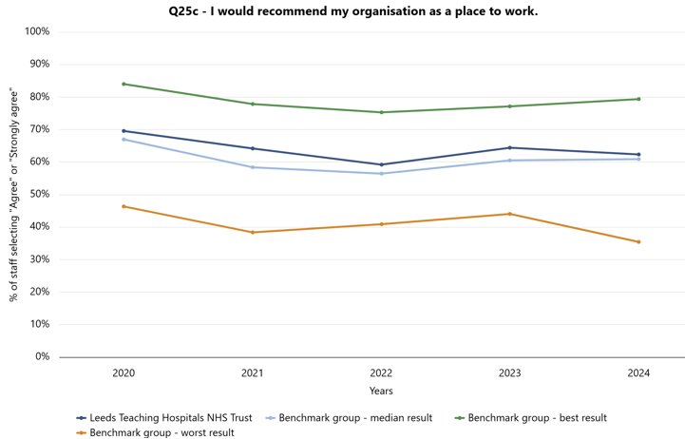  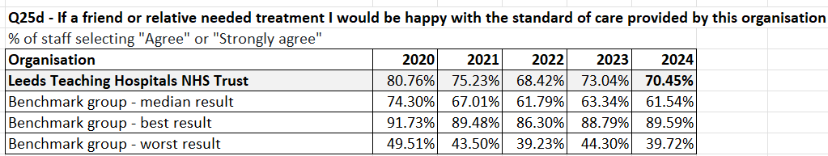  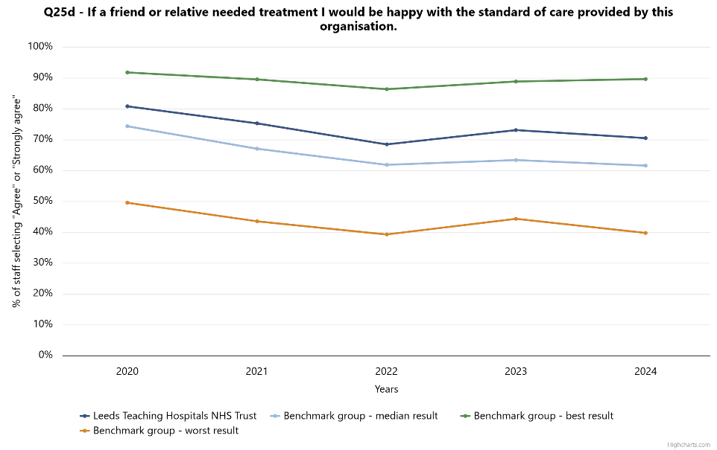  NHS Staff Survey Results:  - Q. I would recommend my organisation as a place to work: 62.34%, a deterioration from the previous year (64.41%), however remains significantly above the national average.  - Q. If a friend or relative needed treatment I would be happy with the standard of care provided by this organisation: 70.45%, a deterioration from the previous year (73.04%), however remains significantly above the national average.  LTHT’s Trust vision is supported by eleven enabling strategies, including the People Priorities. The five People Priorities enable us to effectively support and develop our People, and include:  - We are inclusive and champion diversity  - We plan, and deploy our people to deliver effective care  - We lead by example- compassionately, effectively and together  - We support each other to be well at work  - As a Teaching Hospitals, we foster a culture of learning and continuous improvement, so our people realise their potential.  Each People Priority is led by centres of excellence, ensuring key priority areas for each are progressed. These People Priorities also support the structuring of Clinical Service Unit ‘Operational Workforce Action Plans’, informed by triangulated Workforce Metrics (varying from turnover data to sickness absence, exit interview, staff survey, pulse survey, and EDI demographics etc.), and ensuring identification and progression of locally bespoke improvements.  In 2024/25 there was a commitment to Improve Retention, which resulted in the following improvements:  - Voluntary Turnover improvement: 8.5% - 5.8%  - Turnover Improvement: 9.6% - 8.6%  - Staff Engagement Score improvement: 6.8 - 6.9/10  - Exit Interview, reason for leaving improvement.  Improvements have been sustained (Nov Vol. Turnover 5.5%) through ensuring the embedding of retention practices into standard work, across all levels of the organisation. | 1  Developing | Suzanne Dunkley, Chief People Officer  &  Beverley Geary, Chief Nurse

