Key Trainer Handbook

Siemens
RAPIDPoint 500/500e System & RAPIDLab 1200 System

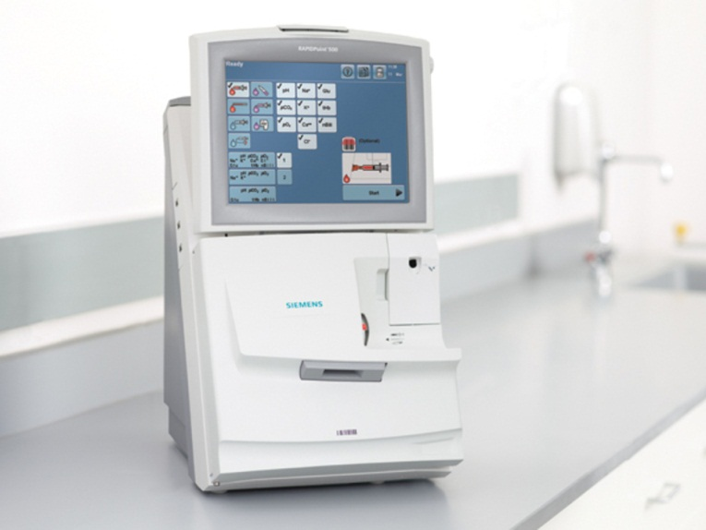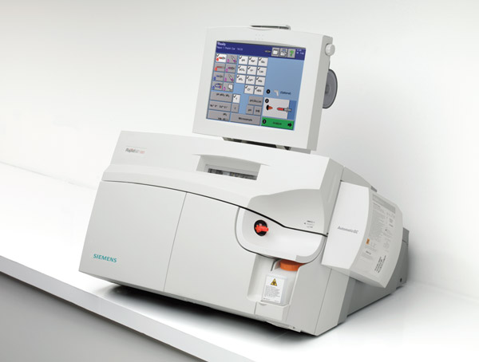

Contents
Introduction | ……………………………………………………………………. | 2
Key Trainer Role | ……………………………………………………………………. | 2
Training Overview | ……………………………………………………………………. | 3
Training Steps | ……………………………………………………………………. | 4
Observational Assessment | ……………………………………………………………………. | 5
Training Certificate | ……………………………………………………………………. | 6
Multiple Choice Questions | ……………………………………………………………………. | 7
Answers | ……………………………………………………………………. | 8
Training Register | ……………………………………………………………………. | 9

Phone: 22338
Email: leedsth-tr.pointofcare@nhs.net

Introduction to Point of Care

This handbook has been compiled by the Point of Care Testing Department (POCT) for LTHT to help you, the healthcare professional, achieve consistently reliable and accurate results. It also hopes to explain the importance of good practice when producing laboratory results outside of the Pathology environment.

The different sections of the booklet cover aspects of working with the Siemens RAPIDPoint 500/500e and RAPIDLab 1200 Blood Gas Analyser including routine use and quality control.

On completing this training all users should be able to analyse samples obtaining an accurate result whilst minimising risk to themselves and patients.

Ensuring Quality

Leeds Teaching Hospitals Trust Pathology service is required to meet the nationally agreed standards set by UKAS, the national accreditation body recognised by the UK Government. A standard is a document that provides requirements, specifications, guidelines or characteristics that can be used consistently to ensure that materials, products, processes and services are fit for their purpose. Pathology is currently using ISO standards to assess their performance. Following the Clinical Area Standard Operating Procedure (SOP) and using the training material provided is essential to us meeting these standards.

The use of analysers by untrained staff, without adequate management supervision of the equipment and without the use of quality control procedures, can lead to misleading results and adversely affecting the treatment of patients.

Definitions

Calibration - A set of known standards are run at different concentrations and used to assess and adjust the accuracy of the analyser.

Internal Quality Control (IQC) - The role of IQC is to monitor the day‐to‐day precision and accuracy of a given assay by comparing it to known values. Best practice dictates both a high and low are run, ensuring accuracy at both ends of the result range.

External Quality Assurance (EQA) - The role of EQA is to provide a broader comparison. Enrolling in an EQA scheme allows one analyser’s results to be compared to many others, both of similar and different methods. It is also performed by a member of staff and so can be used to monitor user proficiency.

Key Trainer Role

The key trainer’s role is to cascade training from the POCT department to all members of ward staff who are required to use the Siemens RAPIDPoint 500/500e and/or RAPIDLab 1200 Blood Gas Analyser. They must ensure all necessary training steps are completed before informing POCT of completed training.

Key Trainers will be expected to attend training session updates and relay any changes in practice.

Training for Siemens RAPIDPoint 500/500e System and Siemens RAPIDLab 1200 System.

Objective
This competency covers the blood gas analysis of arterial, venous and capillary patient samples using the Siemens RAPIDPoint 500/500e and RAPIDLab 1200 Blood gas analyser in a Point of Care (POCT) setting.

Assessment
This assessment is relevant to anyone required to carry out arterial, venous or capillary blood gas analysis on the Siemens RapidPoint 500/500e and RapidLab 1200 Blood Gas Analyser. This includes having an understanding of how to collect an appropriate sample, how to use the analyser to perform a patient test, all relevant health and safety issues, who to contact for machine failure and the importance of password protection.

Other Helpful Documents

- Siemens Blood Gas Analysers User Guide [BSF2POC181]
- Siemens RapidPoint 500 Blood Gas Analyser Operator Manual [BSF2POC096]
- Siemens RapidLab 1200 Blood Gas Analyser Operator Manual [BSF2POC106]
- Use of the Siemens RapidPoint 500 Blood Gas Analyser SOP [BSF2POC111]
- Use of the Siemens RapidLab 1200 Blood Gas Analyser SOP [BSF2POC040]

This document is for use within the Leeds Teaching Hospitals NHS Trust ONLY. It should not be printed, but accessed electronically so that only the most up to date instructions are available.

PLEASE NOTE: The sharing of passwords is against Trust policy, both the Data protection policy and the use of computers policy. Every member of staff is required to undertake mandatory Information Governance (IG) training and should be aware of this. Sharing passwords breaks principle 7 of the Data Protection Act (1998), which could be interpreted as unauthorised processing. This is unlawful under section 55 of the Act. It is also an offence under the Computer Misuse Act (1990).

Training Steps

The below steps are required for a staff member to be trained and gain access to the equipment. All documents that require completion during training can be found in the pages below.

Observational Assessment: Performing a patient test on the Siemens Blood Gas Analyser

The following assessment must be completed by the trainee and observed by the key trainer to certify them as competent before the training register is submitted to Point of Care.

Knowledge
Has the member of staff read the Siemens User Guide [BSF2POC181]?
Has the member of staff completed the questions (optional)?
Competency

Sampling can be done with either patient or QC sample
Did the member of staff correctly use the relevant ID
Operator ID?
QC or Patient’s ID?
Sample Analysis using QC or patient sample
Did the member of staff expel the air and mix the sample?
Did the member of staff expel the first couple of drops?
Was the sample applied to the sample port correctly?
Did the member of staff demonstrate effective health and safety measures?
Were gloves worn?
Was the used syringe/capillary disposed of in a clinical waste or sharps bin?
Was the machine left clean for the next user?
Skills
Maintenance
Does the member of staff know how to clean the analyser and which products to use?
Does the member of staff know how to replace the sample port?
Does the member of staff know how to replace the printer paper?
RAPIDLab 1200 Only – Does the member of staff know how to replace the waste bottle?
Does the member of staff know how to contact Point of Care in the event of machine breakdown?
Result Reporting
Were the results reported according to ward/departmental procedures ensuring the correct patient ID?
Were the results acted on accordingly?

Please note: If you are analysing a test sample during training, please enter POCT TRAINING as the patient ID.

Once all competencies have been completed and observed, please complete the training register and email to Point of Care Testing at leedsth-tr.pointofcare@nhs.net


This is to certify that

__________________________________________________

has attended the

Siemens Blood Gas Analyser Training

Please tick to indicate which analyser training has been completed below
RAPIDPoint 500/500e | RAPIDLab 1200 Key Trainer

This staff member is certified as competent and will have access
to the analyser for 2 years from the date of training


Trainer Name ___________________

Training Date ___________________


For more details on performing tests on the Siemens Blood Gas Analysers please access the Siemens Blood Gas Analysers User Guide [BSF2POC181] via the Pathology Website:
http://leedspath.myeqms.com/Administrator/LoadDocADM.asp?ID=99349&Ext=True&CCID=1

Point of Care Contact details
LGI: 22338
SJUH: 64791
Mobile: 07775996028
Email: leedsth-tr.PointofCare@nhs.net

Training Checklist

*To be printed on the reverse of the certificate and marked off by the trainer*

Governance
- Operator ID and DOB
- Password sharing
- Training every 2 years
- Correct patient ID- importance for EPR

Analysis
- Sample collection
- Pre-analytical concerns & sample preparation
  - Air contamination
  - Clotting
  - Delayed analysis
- Sample types
- Parameter availability (failed calibration/QC)
- QC & calibrations
- Sample analysis sequence
- Staff member analysed a sample

Results
- Results flags & symbols
- Result recall

Health & Safety
- PPE
- Cleaning the analyser and surrounding areas

Troubleshooting
- Replacing the sample port
- Replacing the paper roll
- Contacting POCT
- OOH procedure

Trainer Name:________________Signature:___________________Date:_____________

Multiple Choice Questions
Circle correct answers:
- What type of syringe/capillary should you collect the sample into?
  - Plain syringe/capillary
  - Heparinised syringe/capillary
  - Any available syringe/capillary

- If a sample cannot be analysed immediately, how many minutes delay is acceptable before analysis?
  - 10 minutes
  - 30 minutes
  - No time limit

- How do you ensure your sample is thoroughly mixed?
  - Re-cap sample, invert and roll between the palms
  - Immediately re-cap sample after collection and expel air through the filter cap, gently invert and roll between the palms at least 20 times
  - Roll sample between the palms a few times

- What should you do if the analyser prompts you to replace the sample port?
  - Walk away and try re-running the sample on a different analyser
  - Immediately replace the sample port, discard your sample and collect a new sample to analyse
  - Replace the sample port and repeat the analysis

- If you have concerns about a discrepant result, you should:
  - Repeat the sample on another analyser if it is within the 10 minute time frame
  - Collect a fresh sample and analyse it on the current analyser and a comparison analyser
  - Send a sample to the lab
  - Contact Point of Care Testing on x22338 or x64791
  - All of the above

- Who is allowed to use your barcode?
- Any trained staff members in the department
- Anyone
- Only me
- Senior staff members

- What forms of patient ID are acceptable?
- PAS number, NHS number or A&E number
- Case note number or bed number
- 0 for unknown patient
- All of the above

Answers
- What type of syringe/capillary should you collect the sample into?
  - Plain syringe/capillary
  - Heparinised syringe/capillary
  - Any available syringe/capillary

- If a sample cannot be analysed immediately, how many minutes delay is acceptable before analysis?
a) 10 minutes
b) 30 minutes
- No time limit

- How do you ensure your sample is thoroughly mixed?
  - Re-cap sample, invert and roll between the palms
  - Immediately re-cap sample after collection and expel air through the filter cap, gently invert and roll between the palms at least 20 times
  - Roll sample between the palms a few times

- What should you do if the analyser prompts you to replace the sample port?
  - Walk away and try re-running the sample on a different analyser
  - Immediately replace the sample port, discard your sample and collect a new sample to analyse
  - Replace the sample port and repeat the analysis

- If you have concerns about a discrepant result, you should:
  - Repeat the sample on another analyser if it is within the 10 minute time frame
  - Collect a fresh sample and analyse it on the current analyser and a comparison analyser
  - Send a sample to the lab
  - Contact Point of Care Testing on x22338 or x64791
  - All of the above

- Who is allowed to use your barcode?
  - Any trained staff members in the department
  - Anyone
  - Only me
  - Senior staff members

- What forms of patient ID are acceptable?
  - PAS number, NHS number or A&E number
  - Case note number or bed number
  - 0 for unknown patient
  - All of the above


Blood Gas Analyser Training Register
Name of Key Trainer:

Date of Training: * competency expires 2 years from this date

Analyser Type (500 / 500e / 1240): * written on the front of the analyser

Location of Training:

This form may be rejected if not clearly readable.
Full Name | Operator ID  *Scan ID badge barcode | Job Title | Ward | Email Address | Observational Competency Assessment Passed | POCT Use Only  Key Trainer
JOE BLOGGS | 12345678 | BSW |  | Joe.bloggs12@nhs.net

POCT Use Only:
RAPIDComm ☐
METRA ☐
GDrive ☐

